Arctis Protocol

User manual for automated milling using WebUI1.3 or Maps/AutoTEM

Cryocycle every…

When system is warm, confirm if the GIS needle needs purging (how?). If so:

* Select patterning tab 
* Set flow duration to 1 min and press purge

# Instrument checks

* Confirm the system is properly cooled down in autoloader tab 
* For cool down, click *Go to cryo* for **both**, chamber and autoloader

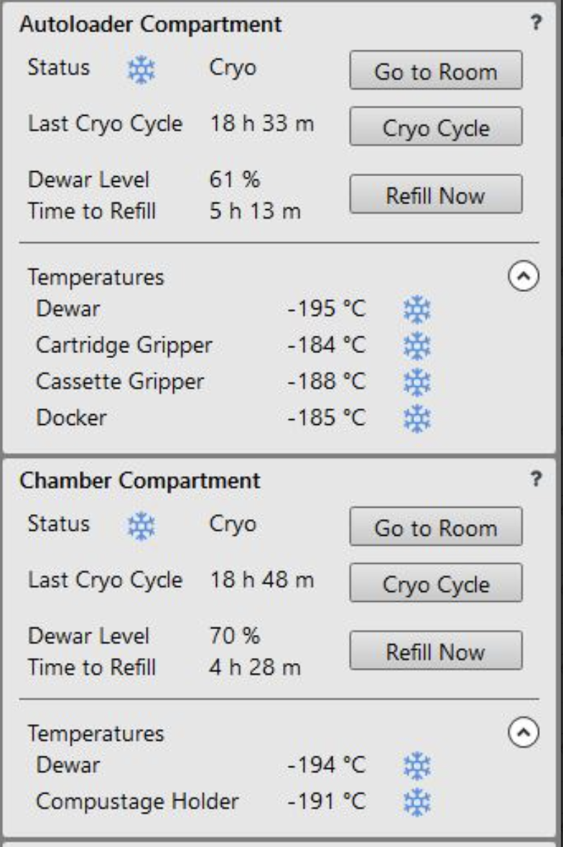

* Select the gas (e.g. Xe), 30 pA
* Check Vacuum Chamber 5e-6 Pa
* No error messages

## Note: During your session, please confirm if the ion beam is well aligned

* Find a non-precious spot on your sample
* Bring it to eucentric height: tilt the stage to -20° and compensate for the shift with the z-height in stage  tab

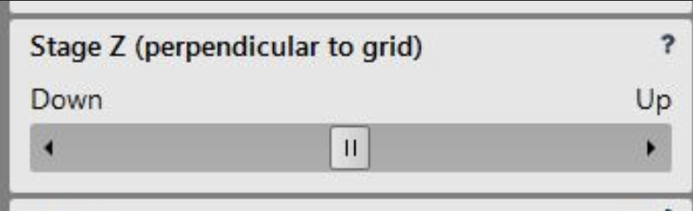

* Bring sample perpendicular to the ion beam: stage tilt -128°
* Center a spot on the grid bar, center an easily identifiable point, increase magnification
* Take images in all currents, you are planning to use in your session. If the central feature shifts between currents or if the image becomes blurry, do beam alignments and beam shift alignments. (Get training for that, first!)

## Wake up system?

# Sample loading

* Prepare loading station:

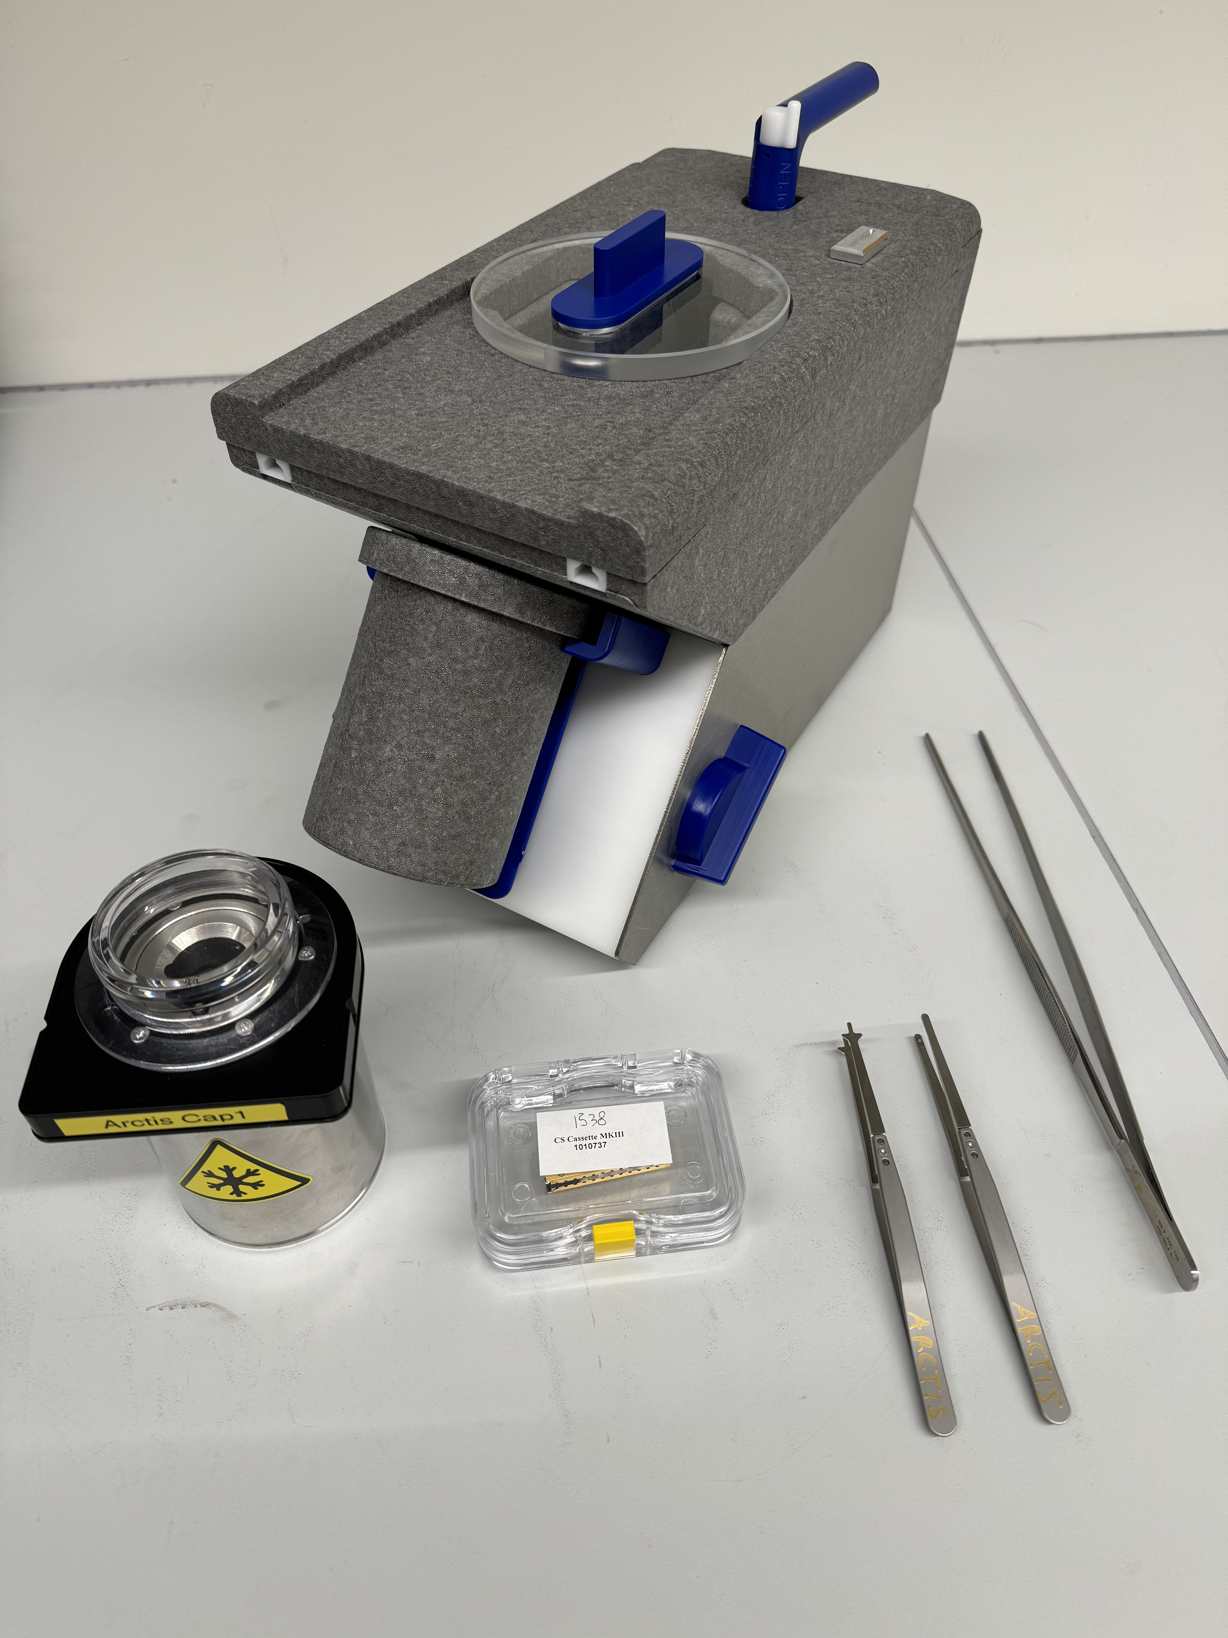

* This can be used as the normal Krios station. Practice the new lids and the transfer handle at RT
* Cool down station and nanocab
* Load grids with cut out facing the front of the cassette/cut out pointing to you while loading

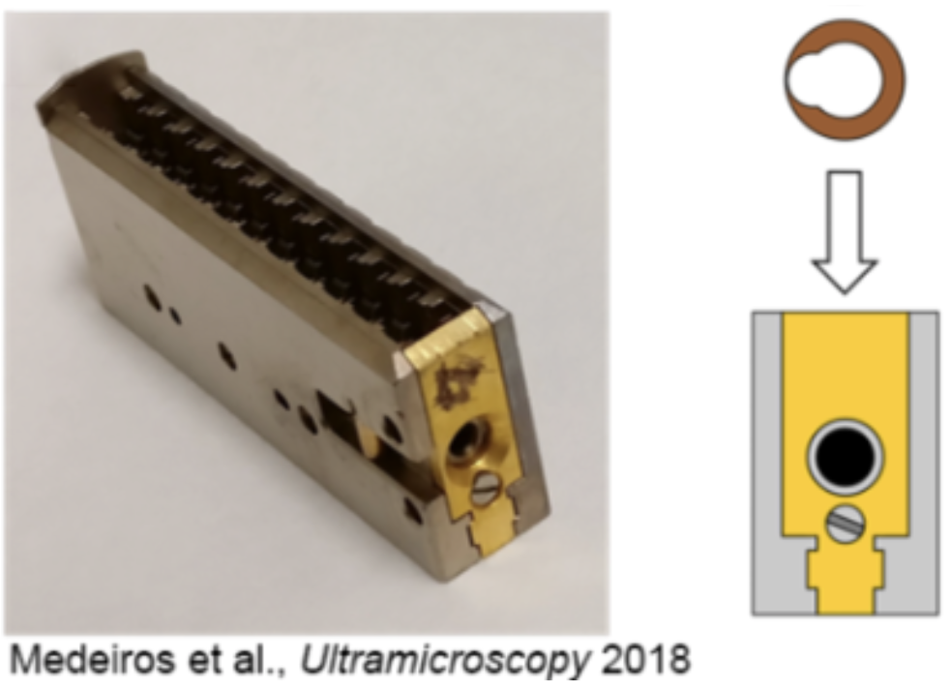

* Transfer cassette to nanocab
* Sliding lid needs to be removed all the way for transfer; the resistance of the slider in cryo is “normal”
* Open arctis door and insert nanocab, press dock cassette on touch screen
* Wait for cassette to be docked and retrieve nanocab as soon as touch screen prompts the message “nanocab can be removed something something”
* Wait for cartridge gripper to cool down (lowest T it can reach is -184°C) to -175°C

# If you are not logged in:

# Automated milling with WebUI

## To connect WebUI

* Start automation service monitor from microscope PC desktop

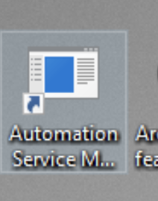

* Automation service monitor will show up in hidden icons

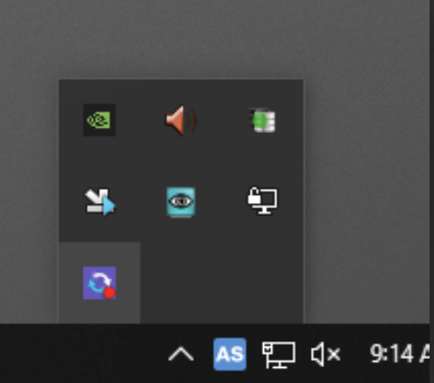

* From this icon you can open the actual automation service monitor window

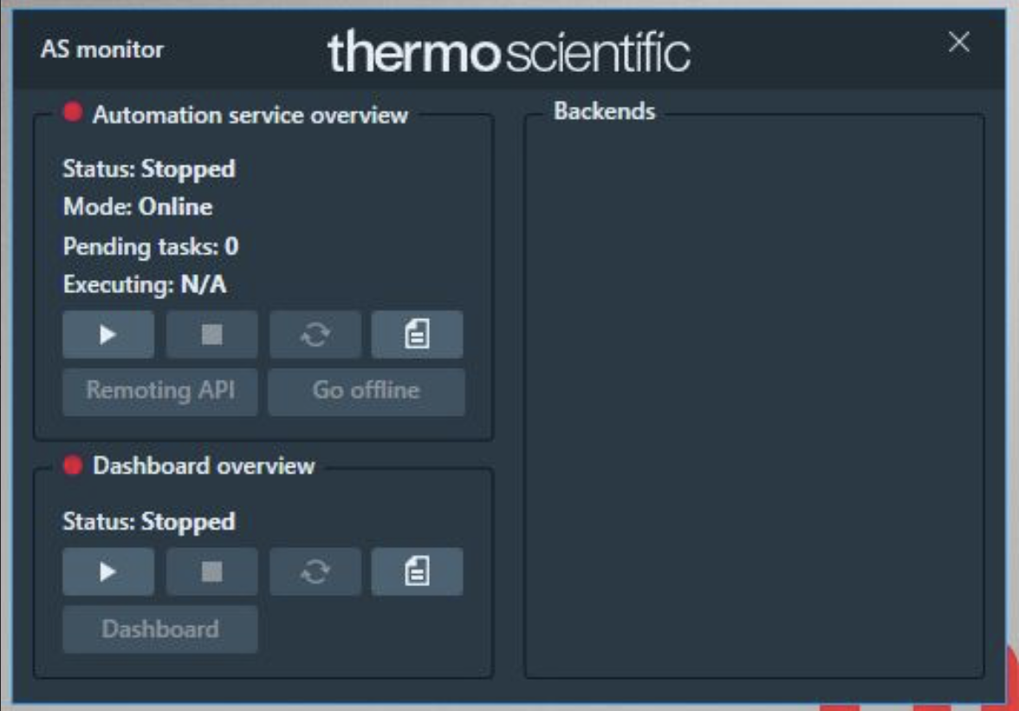

* In automaton service overview click play
* Automation service terminal will open
* In automaton service overview click go online
* In dashboard overview click play
* In dashboard overview click dashboard
* process executed by WebUI
* In the Back Ends tab, make sure correct backend is running or start it; please confirm with Uli if unsure which backend to use

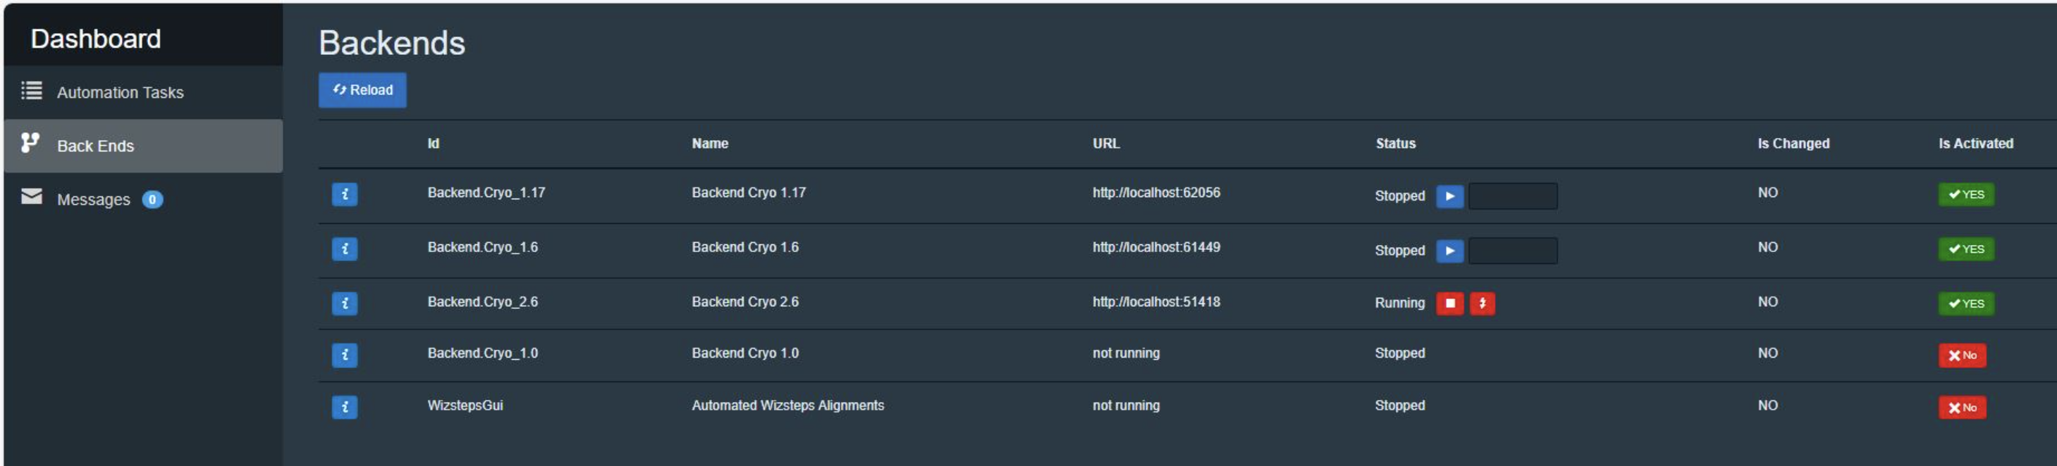

* Connected AS monitor will look like this

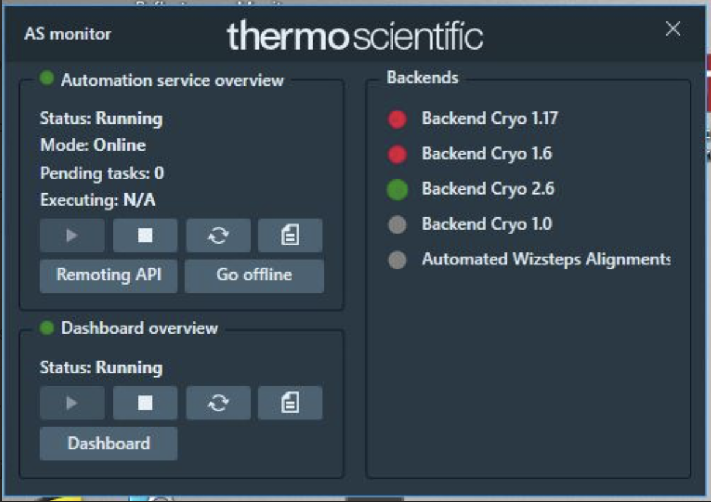

## Login:

## Start WebUI session

* Open a second and third tab with WebUI 1.3 from the bookmark

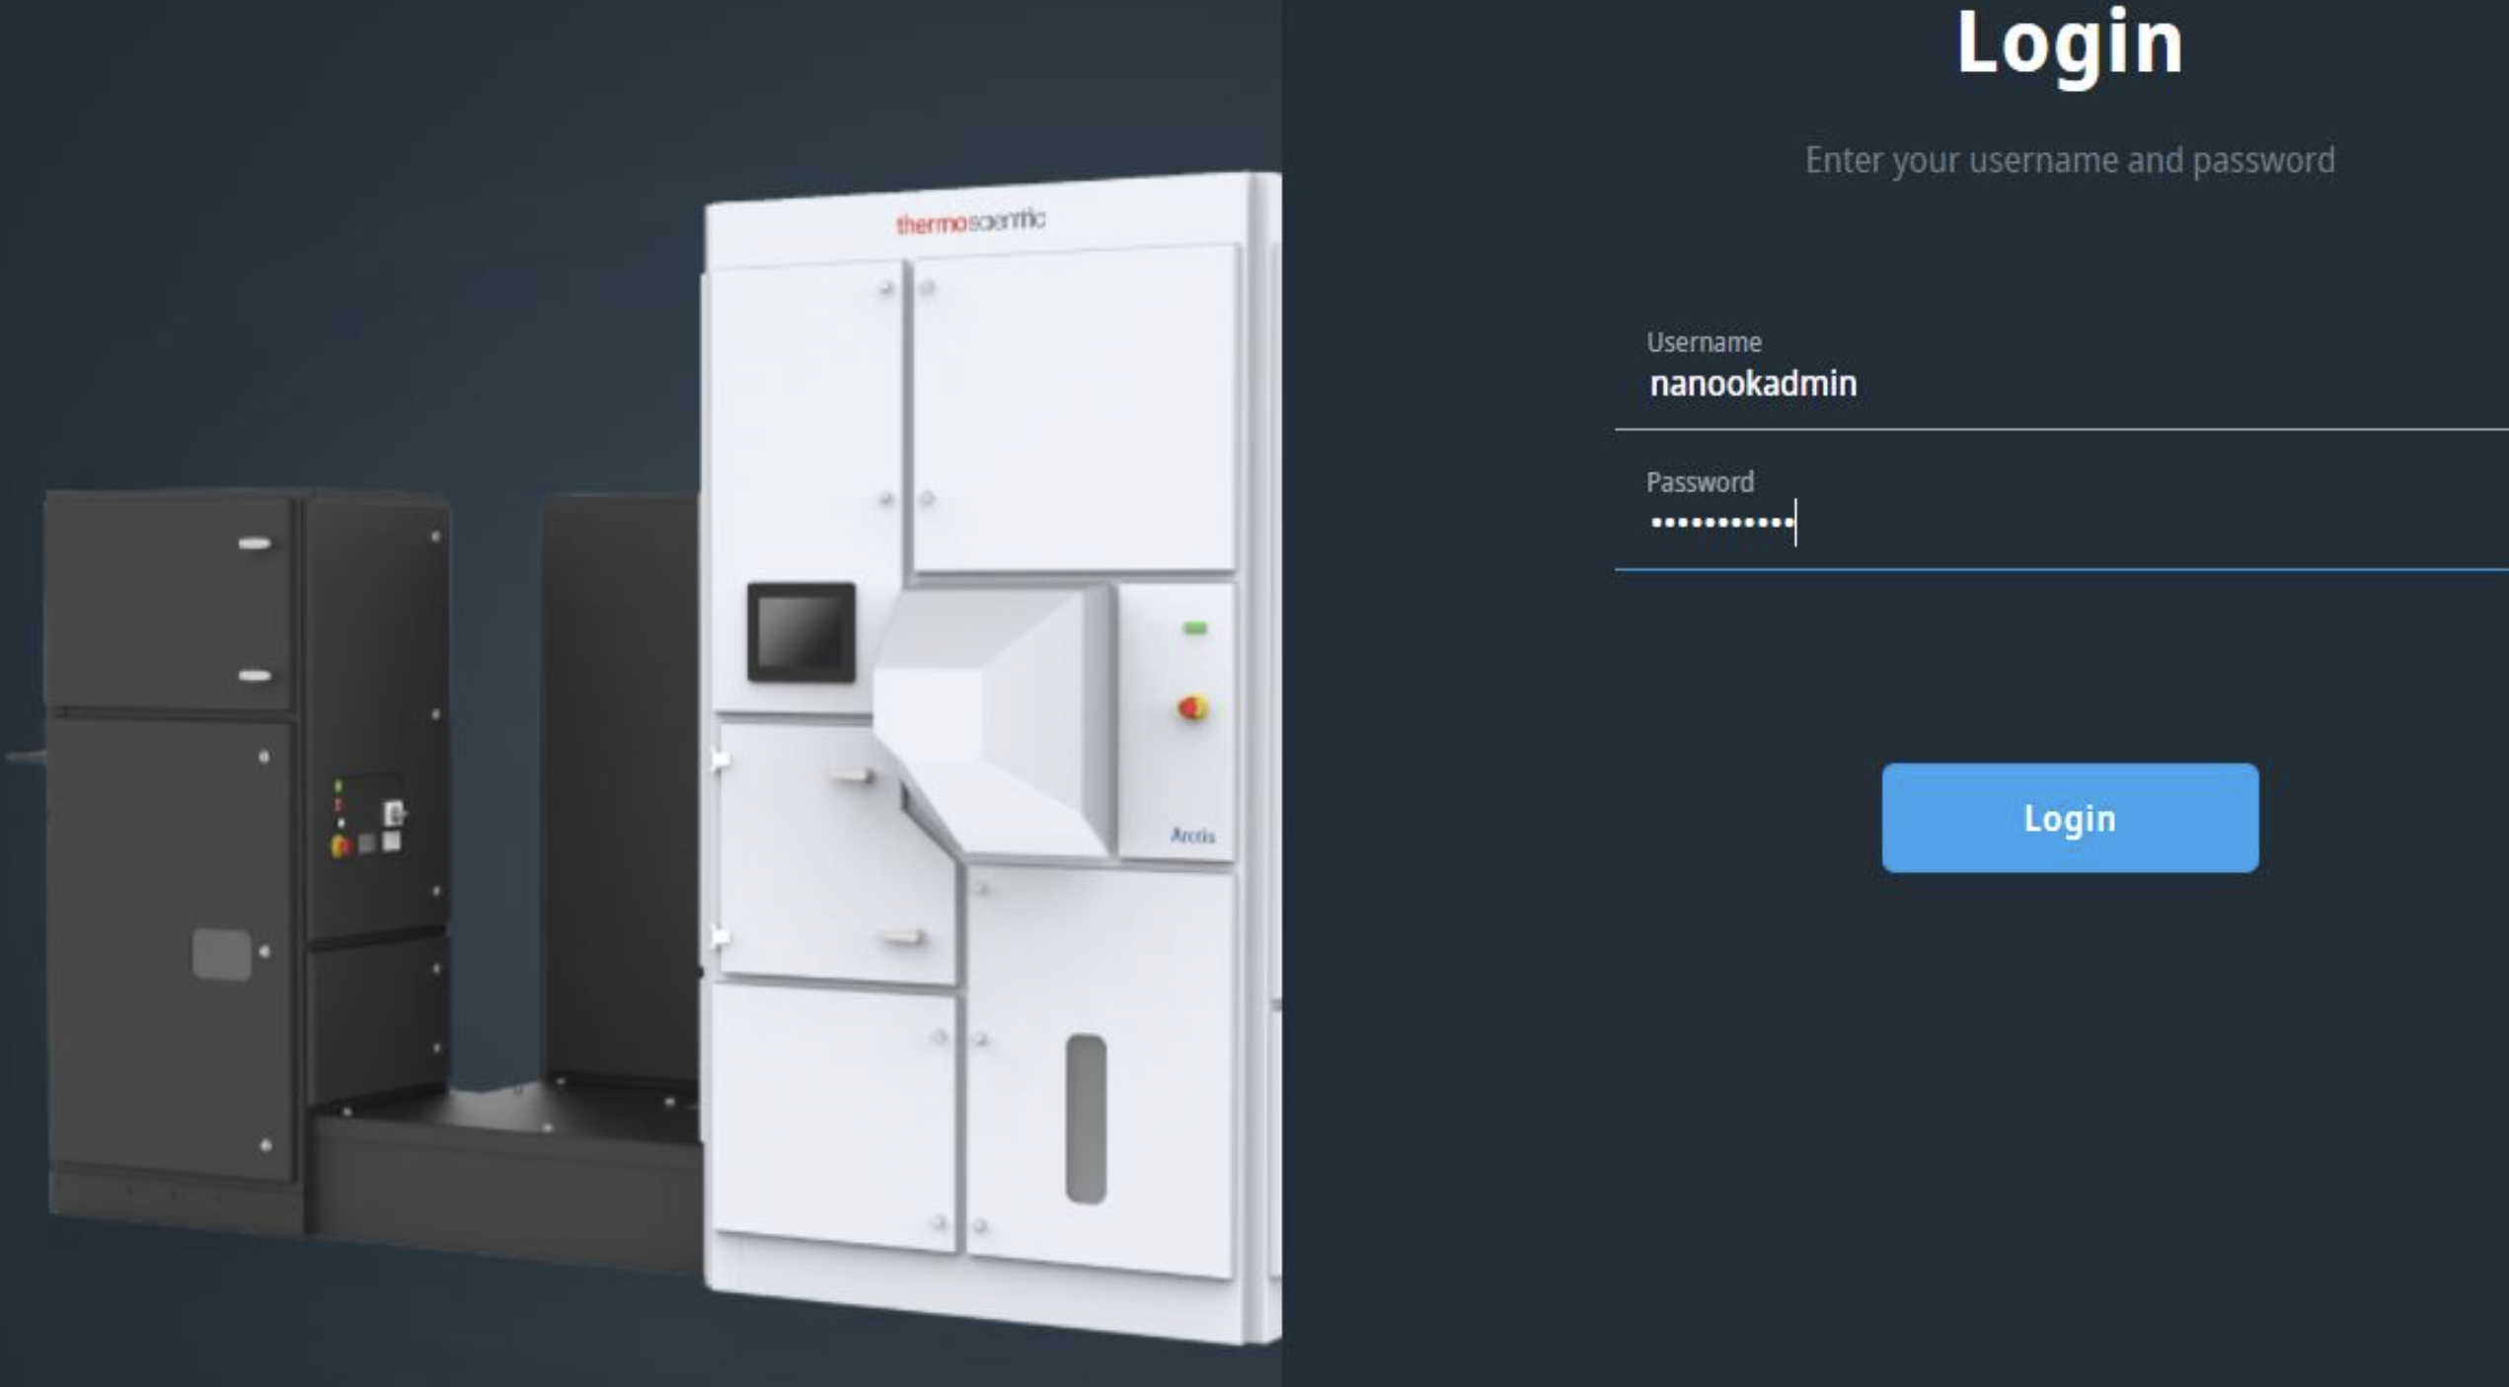

* Login with same username and password
* Use first webui tab for project
* Use second tab to display templates
* WebUI 1.3 does not have any projects anymore
* Grids tab corresponds to your project, select it

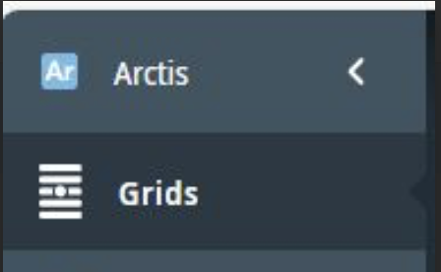

* Click run inventory. If you did it in XT, this will be imported when you click “Run inventory” > not true for me the second time, it re-runs inventory



* Pop up will ask you for confirmation to over-write last users inventory

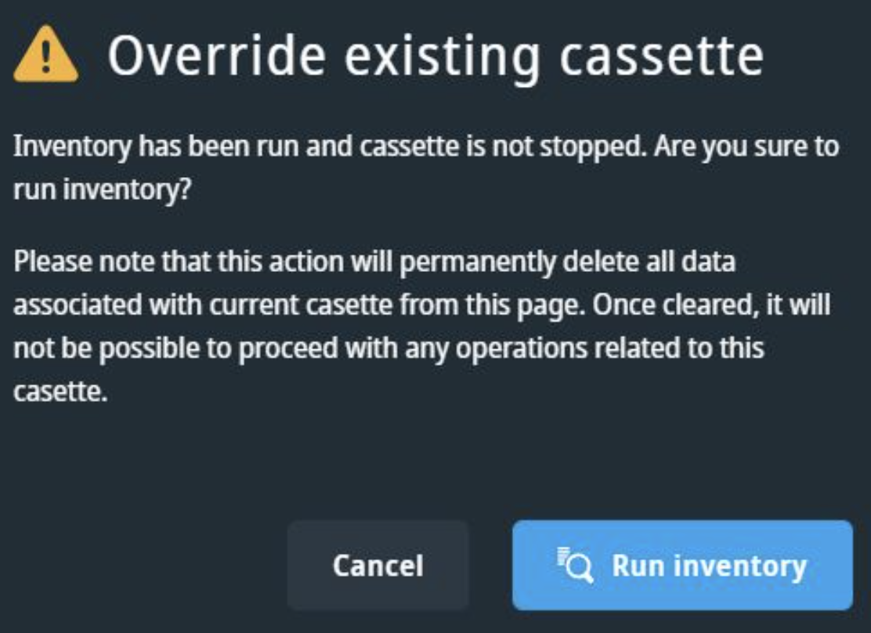

* After inventory, Grids will appear with options
* Stopping the inventory aborts the process, no grids will appear – so be patient!
* On your first grid, click on “Add overview image – high res”, it will start
* Then click on Tile Set, select Electron tile set, schedule it
* Repeat for all grids.
* Save grid settings from your grids, will be moved to grid history later. This will help you find your data. Use your name as a label

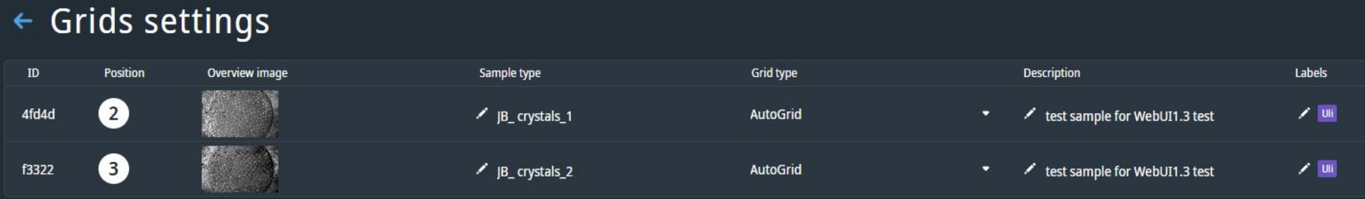

* Acquire tile sets and overview images for each grid
* If you need optical tile sets, plan at least 2 hours per grid
* Chose a template, select lamella sites and follow webui

## Template development

Go to the template tab:

There are all templates, we select lamella targeting workflow

* All templates will come up
* Select 3D Targetting lamella template – Xe -Uli – Fiducials (Select the Gas in XT)
* Now you see the detailsed, there is the option 3D Targetting multiple time and Optical Stack acquisition (make sure it is green / red) for all selected steps

Go back to grids: Now we want to sputter! Click on Deposition, Bulk deposition – 100 sec GIS– Xe! (Thickness is gas dependent! > how do you determine length?) There is a polygon on the FIB Camera showing a circle (not the sample, something – what?)

Chamber pressure during Sputtering is 6.1 * 10°-6 Pa

Where does the sample / stage go ? Having an idea what happens in the chamber

**Do a tileset to confirm sputtering**

Do an optical tileset as well before selecting lamella sites?

Go back to Grids. Upper right, select template. Left select “place lamella 1” click Lamella targeting workflow, make sure template is what you want, then on top you “Save lamella”

The Lamellae template will start automatically. You need to chose the sides before the optical stack (unless you acquire an optical stack).

Where to place fiducials?

Can I cancel process for one lamella and move to next?

Lamella Assessment:

Your lamella finish with EH, milling angle and fluorescence collected.

Some lamella may not be sharp in the FIB, or the focus is place on the grid bar not the target? 🡪 How to fix this after all images have been acquired?

Anyways, we proceed in Action Overview and place ROI and fiducials:

Lamella 5: 3D targeting

Move to plane with sharpest fluorescence, place your ROI

Then place 2 fiducials around it, maybe 3 to have a triangle. What the best plane for fiducials?

Say done and then you will see a new window with optical 2D projection on the left, and your FIB image on the right. Enable the fiducials in the FIB image to move them to the position as in the optical image.

Repeat for the next lamella.

Then go back to Action Overview and define the lamella milling positions. It will start immediately.

After Webui finished, perfect lamellas

* Wake up Beams (if they sat idle for 60 mins they will turn off)
* Switch to Argon (takes 5 mins)
* Retract iFLM objective

You cannot navigate in Webui. To go to Lamella Site one, take an Overview Image with the lamellas.

# Manual Polishing with Argon

Preparation:

* First go to your lamella site 1 at low magnification
* With GUI, calculate stage position at you milling angle.
* With stage position on lamella sit, update SEM image
* Iteratively change z (to a positive value) and update SEM, then center FIB
* Center lamella in FIB
* Change z
* Update FIB (30kV, 6 pA 2/2, 300ns), center lamella
* Update SEM and update FIB (ion Beam comes from top in XT, and from botton in WEBUI)
* Z-height is around -22 um
* Now with reduced area run focus, and ACB
* 1st pollishing setting: 50 pA, ~300 µm pattern distance (cleaning cross section)
  + Add 2 object (make sure thick lines twds lamella)
  + Aligne them to Center
  + Do line measurement to get the distance
* 2nd pollishing setting: 30 pA, ~130 - 230 µm pattern distanceadobe

Grid Finalization. 5 Sec Template

# General Troubleshooting

Take Overview

Tilt Set

Deposition (Xe, 120 – 100 – 120)

Tile Set after Deposition

Select Lamella Sites

Run…

Short Sequence

1. Run Inventory
2. Run Overview
3. Run Electron Tileset SEM
4. Optional: Run Tileset Optical (takes 2.5h/grid)
5. Run Deposition
6. Re-run Electron Tileset after Deposition
7. Run Lamella Targetting Workflow

**Parameters**

* Basically all default
* Tile Sets
  + Turn off EH in Ion tileset
  + Optical
    - Faster: Stack parameters : Stack Thickness : 8um
    - Better resolution: 15 um
* Deposition:
  + Xe: Sputter 120 – 100 s gis – Sputter 120
  + Ar: Sputter 240 – 100 s gis – Sputter 240
* 3D targeting lamella template (save at every step)
  + EPS : Maximal tilt step: 35° (instead of 10 default)
  + (optional: Big Fiducials 20 um apart (instead of 15 um))
  + Milling angle search:Target angle 10°
  + 3D targeting on: 15 um thickness
    - optical stack acquisition: Imaging settings wise, binning 4, slice distance 500 nm
    - automatic exposure time
    - optical image acquisition (by sample type): CG 0% / LED 60% > you may change it to CG 20, LED 20%
  + Lamella Placement: change front and rear pattern width
  + Relief cuts: 1nA usually fine, unless grid very dry
  + Milling patterns 100% depth, regular cross section
  + Rough Milling: Final image: 3072x2048 resolution, Horizontal field width 50um (don’t go below 25), turn off drift correction it messes up at high currents
  + Turn off Small Fiducials, only necessary for clean samples without many features
  + 3D targeting, imaging settings, binning 2, 300 nm slice distance, again CG 20%, LED 20%, stack autofocus params 15 (you can reduce it for time)
  + Medium milling, 75% depth correction, rear pattern overlap 250%, left width overlap 500 nm, right 500 nm, 50% height correction
  + Fine milling drift correction updated to 90s, remove height percentage 80%, depth correction
  + Polishing : remove 100% of height, 60s
  + Last optical stack: binning 2 (for high res TEM alignments), stack 12 um, drift 60s
  + SAVE
* Place Lamella site (circle), it will start processing immediately until lamella positioning
  + **Investigate results on the fly**
  + Judging rough milling depth correction on the fly and correct template
  + Is optical image saturated?
  + Optical 2D projection vs Ion:
    - If you used big fiducials, you will have 2 X, chose the best one to position your target, targeting yield 60%
* Check im Lamella is being milled as you planned to, you can change parameters of each individual lamella on the fly
* Place more lamella sites, they will queue
* Sputter coating after lamella is created

Note:

* **Read the manual**
* Xe causes more deposition on the lamella front end
* Xe may cause holes in Pt-cap
* You can stop actions in XT and WebUI will move forward
* Purging GIS with every cryo-cycle
* Compustage drift (increases if grid not grounded)
* Fluoresecence signal is strong enough to go through gis layer
* Remove height percentage 50% related to milling pattern before 50% above and 50% from below
* Judge speed vs quality
  + 1nA Ga, Xe, Ar …
  + For polishing times go slow and close
* If FIB is fuzzy it may indicate poor beam alignment
* 1 nA ACB causes “square pattern for each image”
* Make sure final image in Template as Autofocus on

**Tweaks:**

* FIB-Alignment
* Pattern Alignment:
  + It sets a pattern, but mills outside?
* You can run the full workflow only with FIB
* Non-uniformity with lamella : find out if overtilting helps

Lamella Rough Milling Exploration

* Rectangle Pattern, 200 depth, most of Pt is gone, erosion around lamella edge
  + You could go down to 150 to have cleaner edges on lamella
* RCS Rough pattern, 200 depth, Pt left, nice edges
  + You could increase depth 250
* Lamella target thickness 250 nm, Polishing Remove height percentage 100%
* Make sure final ion image in Template as Autofocus on

Ion tileset Template w/o EH

**Day2: Lamella template for Thick samples or Waffle**

* Default GIS Position is at -10°. We flipped grid by 180 to -190°, but then we cannot insert the GIS
* Miling from below: no GIS, unless service mode: go to default GIS Dep Position: -170, x-y-z : 0,0,-1mm; then you must do : Ask you service engineer (CT thinks its “Test GIS on Behaviour”)
* Milling from top: GIS is there, we cannot see grid bars

What we do:

* Acquire electron tile set
* Deposition as before (you can watch GIS in SEM live view, 64kx, 2kV, 25pA), 500 ns
* Reacquire electron tile set
* Define Template “Apps Training – high milling angle” :
  + 500 nm fiducials
  + Rough milling with Rectangle pattern (We will stop after this step)
  + Target milling angle 50°
* Pick 1 lamella site, apply template and see what happens
  + It failed with milling angle 50° 🡪 but it doesn’t tell you the appropriate range
  + Adjust template to milling angle 25°
  + Go to finished actions, filter by your grid 4, or filter by failed actions, re-run action with the highest angle working (25°)
  + Adjust beamcurrent 30kV, 1 nA for milling
  + 1.5 um above lamella and below, mill at 1 nA until through, interrupt the process
  + Issue with HPF: where to place lamella : far below or on top; how do you reapply GIS to make sure the lamella is still protected (check Paper)
* We notice limitations with WebUi
* We update the Grid name, then go to grid history and export that grid to MAPS (Tile Sets only)
* Export.zip

**We move to Maps**

* Make sure stage is at 0°
* In AutoTEM: Microscope : set stage to 0°
* Import : Export. : *.tfs File
* In Settings make sure Cryo Is turned on
* Add lamella site

**We open AutoTEM Cryo**

* Import Maps Project (gives error: restart MAPS and AutoTEM)
* Anyways, we continue. We load High Angle Milling Preparation.
* When you export the template, you can duplicate jobs in textfile
* Move to preparation.
* Do EH with features “Update button allows you to add features”
  + Set proper resolution for EH
* Make
* Set miling angle 53, take an image
* define Rough Milling parameters
  + Place Lamella position
  + 1 nA
  + For safety: DCM Rescan Interval turn Off (else it will scan with 1nA)
* The front pattern is the top pattern, the rear pattern is the back
  + 120% depth correction, 1nA
* Status: we milled through, and a thick chunk is standing
* Update image
* Replace lamella site, but we need to do it at new milling angle (-20°) that allows you to see the ice underneath
* As long as your lamella sits on the PT-cap, you are safe, else you need to explore GIS reposition

Thinning:

* Usually 1 polishing step with 1 beamcurrent, e.g. 30 pA
* Polishing with 10pA if you want a second round

Move to next grid-square

* Go through preparation, make front window manually using rectangle: x 15, y 11
* Now we set a to 15° to deposit GIS
* We check GIS deposition on lamella with TrinityT1 (Back-scattering will show up deposition)
* We have to change a – to make the side of the grid accessible to the GIS, so milling a wedge for deposition
* Make ramp
* Deposit 30 sec GIS on that site
* Now you want to mill your lamella
* Medium RCS 1
* Fine CCS 1
* Polishing with overtilt 100 nm target with Overtilt of 0.3° or smaller (to get rid of overtilt) -> UL will talk to AR to implement Overtilt in Webui

Important: Make sure you have a clean surface! The lamella looks perfect. You don’t need to switch gas.

**Setting up an Argon Template**

* We used Xe and switched to Argon
* Restart AutoTEM cryo, so it will apply to correct values for miling

**CryoSliceAndView with StageBias (Aquilos) to be explored**